**Balsam Poplar Phenology Observations in Common Garden**

At each site the phenology observations were recorded by the same personnel walking through the common garden every alternative day during spring and twice a week in summer and fall. A scale of 0 to 11 was used to describe the different phenological stages.

**Spring phenology**: During early spring, the developmental stage of the terminal buds of each tree was scored on a scale from 0 to 3 (**Figure 1**).

0 = dormant bud

1 = bud swollen/green tips

2 = bud flush

3 = leaf emergence [very small leaves with visible petiole]

Here, leaf emergence Julian date is considered as the first day for the green-cover duration.

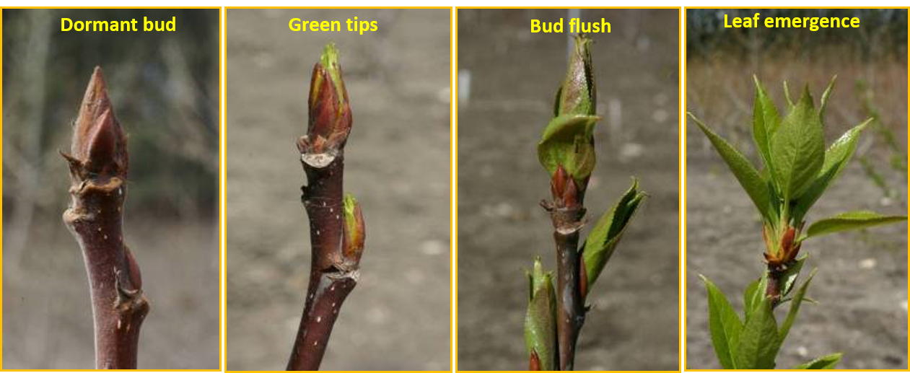

Figure 1: Spring phenology stages.

**Summer & fall bud set:** Within a few weeks of leaf emergence we began scoring the condition of the apical meristem of the current-year terminal shoot on a scale from 4 to 6 **(Figure 2).**

4 = current terminal of the main stem actively growing

5 = terminal bud beginning to form on shoot apex

6 = terminal bud fully developed and covered by dark brown scales;).

We also, record lammas growth (i.e., secondary midsummer flush) using the scale 7 and 8 **(Figure 2)**.

7= newly formed buds re-flush

8 = set the terminal bud again after a short period of growth

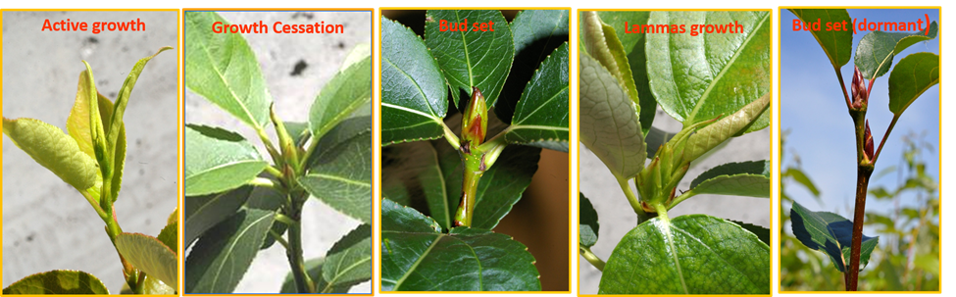

Figure 2: Summer and fall bud set stages.

**Leaf senescence:** The leaf senescence dates in autumn were recorded on a scale from 9 to 11, using the Swedish aspen senescence score card (Fracheboud et al. 2009; **Figure 3**).

9 = ~25% of the leaves on the tree have turned yellow

10 = ~50% of the leaves on the tree have turned yellow

11 = 100% leaf drop.

The tree-averaged green-cover duration was calculated as the difference between the day of the year (DOY) recorded for stages 3 and 10.

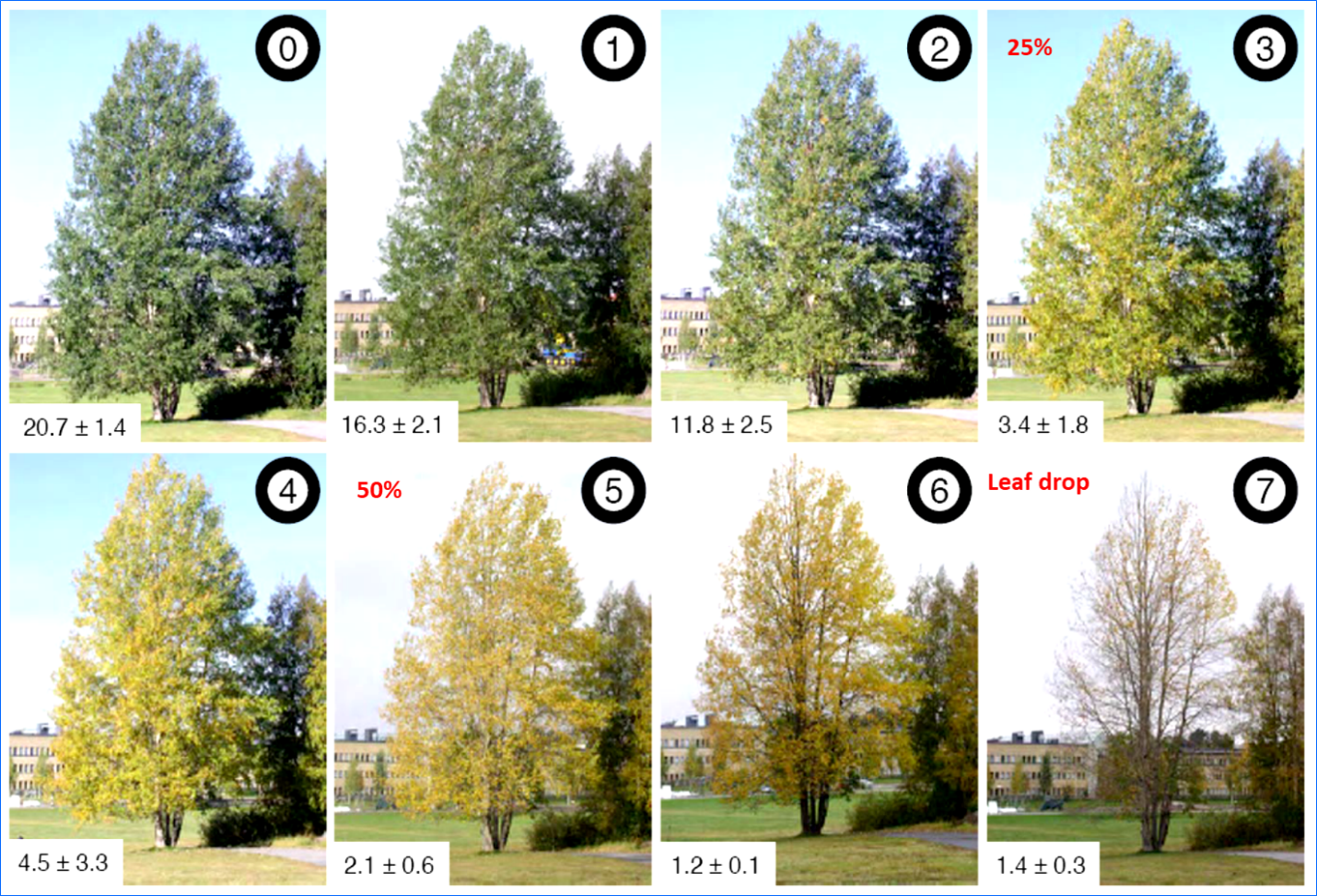

Figure 3: Autumn leaf senescence stages.